Guided Journaling Exercise 1
Step 1: Write a sentence about what just happened.
Step 2: Identify the emotions you’re feeling
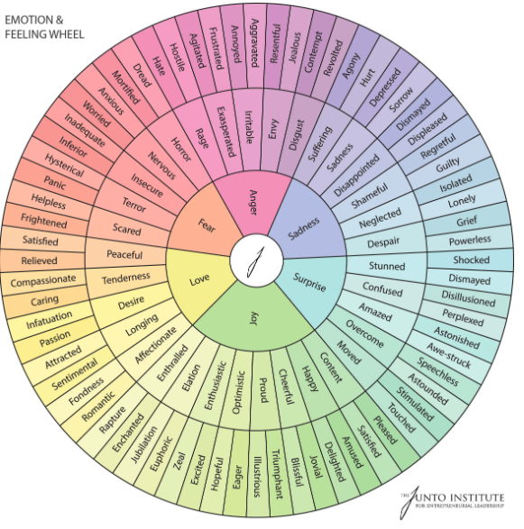
Step 3: Validate. Feeling X makes sense because _______, and because _______, and because _______.
Step 4: Identify the emotional need. What is your emotion telling you that you need?
Step 5: Can you take an action to fulfill that need?

Guided Journaling Exercise 2
Step 1: Describe the situation you are thinking about/would like to process in factual details. Avoid adding your own perception and interpretation, and avoid adding emotional detail or assumptions.
Step 2: Describe what was within your control or influence and outside of your control or influence about this situation.
Step 3: Describe how the situation made you feel. Be as descriptive as possible.
Step 4: Validate each of your emotions. Tell yourself why it makes sense that you feel the way that you do. Allow your emotions to be there. Avoid judging them or trying to get rid of them. Use the knowledge you have of yourself (e.g. your past, your goals, your values, your personality and preferences etc.) to validate yourself.
For example:
- I can understand why I would feel embarrassed by what happened because I want others to see me as competent and smart and I’m worried my behaviour didn’t demonstrate that.
- It makes sense that that makes me angry, because that goes against my value/belief/moral of ‘x’.
- That was really scary for me because of how much I care about my relationship. This made me feel my relationship was in danger.
- Of course I would feel anxious about this party, because there are a lot of unknowns and a lot of new people to meet. Meeting new people has always been hard for me because I worry about them judging me.
- It makes sense that I would feel disappointed that I didn’t receive recognition from my friend because I want them to know how much they mean to me, and having my friends feel cared for is important to me.
- Of course I am feeling hopeless about this working out because I’ve tried a few different things already and they haven’t worked out. I’m not sure about the next step to take and that’s kind of scary.
- I am feeling worried and anxious about my test results. That makes sense because I value my health and my life.
- I can understand why I would feel angry because of that because it felt like I needed to defend myself. Along with feeling angry I was also feeling hurt.

Some sentences to use to validate your emotions include:
It makes sense I feel ‘x’ because of ‘x’
Of course I feel ‘x’ because ‘x’
I am feeling ‘x’ because ‘x’ and that’s okay.
My feeling of ‘x’ is showing up because ‘x’
Feeling ‘x’ makes sense in this situation because ‘x’. I’m sure most people would feel similarly (or) that’s a natural human response to feel that way.
Step 5: If action is needed, create a compassionate goal. Set a goal and remember to express to yourself why you care about that goal. Once you set the goal, create up to 3 ways in which you can take a ‘first step’ towards working on that goal. Think of these as rungs on a ladder, create steps far enough to reach but not high enough that you would have to leap to.
Example:
- My goal is to express myself without yelling. This is important to me because I want to express what I am actually feeling and have a conversation with others. Other have also said it’s their preference for me not to yell.
  - Step 1(a) In order to express myself without yelling I could work on deep breaths/grounding skills to stay present in the moment regulate my emotions.
  - Step 1(b) I could work to take breaks when I feel myself wanting to/starting to yell.
  - Step 1(c) I could ask someone I trust to help me work on this goal (e.g. please remind me by saying ‘x’ to take a break or to take a breath, when I start to yell please do ‘x’
- My goal is to go to the networking event even though it is making me anxious. I care to work on this goal because I think it would benefit my career and I care deeply about advancing my career.
  - Step 1(a) I could practice networking conversations with a trusted friend or family member.
  - Step 1(b) I could attend counselling or read online about anxiety regulation strategies such as breathing techniques and grounding techniques and practice these so I know how to soothe my anxiety during the event.
  - Step 1(c) I could ask a trusted colleague to attend with me which may help me to feel safer at the event.

